# Visualisation of Force Fields

In the paper by Goyal, Runia (Wear, 1991), limit surfaces are discussed representing the net frictional force and the moment between a rigid body and the surface on which it slides. Below we try to analyse these surfaces for few trivial cases and then for continuous surface patches.

The surfaces are defined by the contact points and the friction strength at those points, then a reference point is chosen C. The limit surfaces are then generated for each case.

## 1 Single contact point

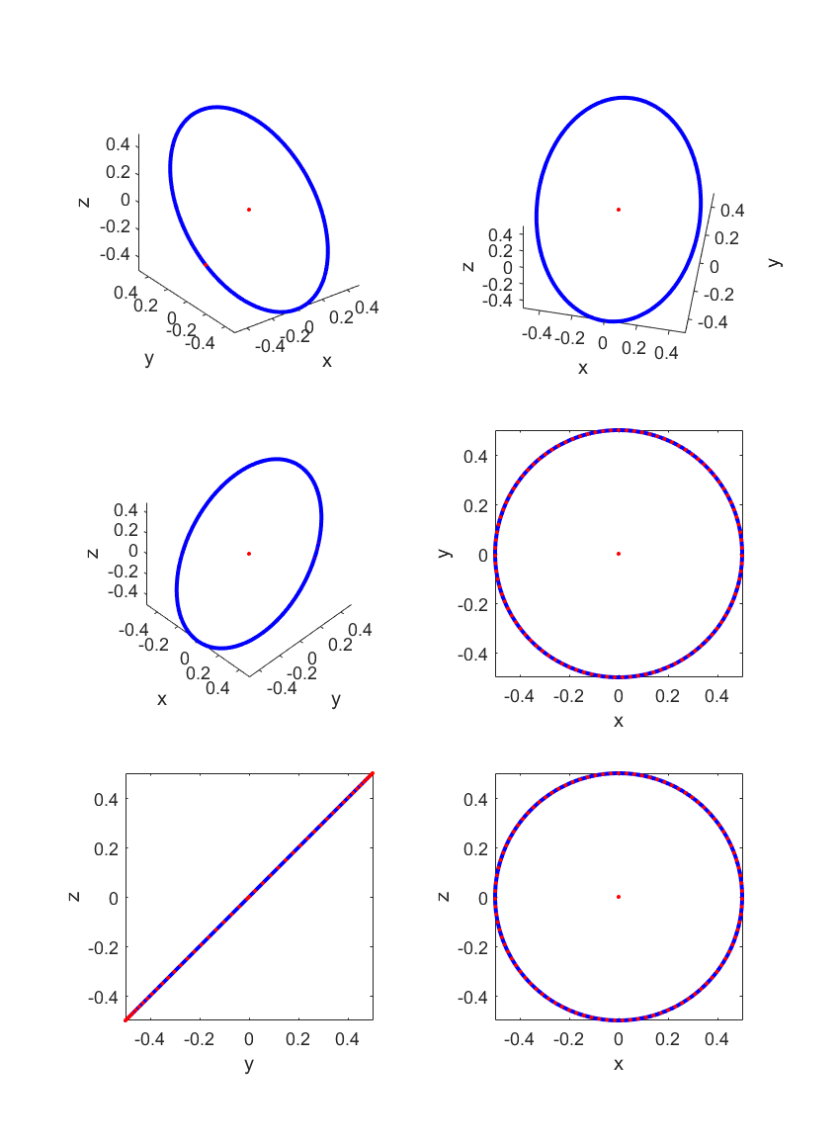

C(0,0)

A(1,0)

## 2 Two-point contact

A(0,1)

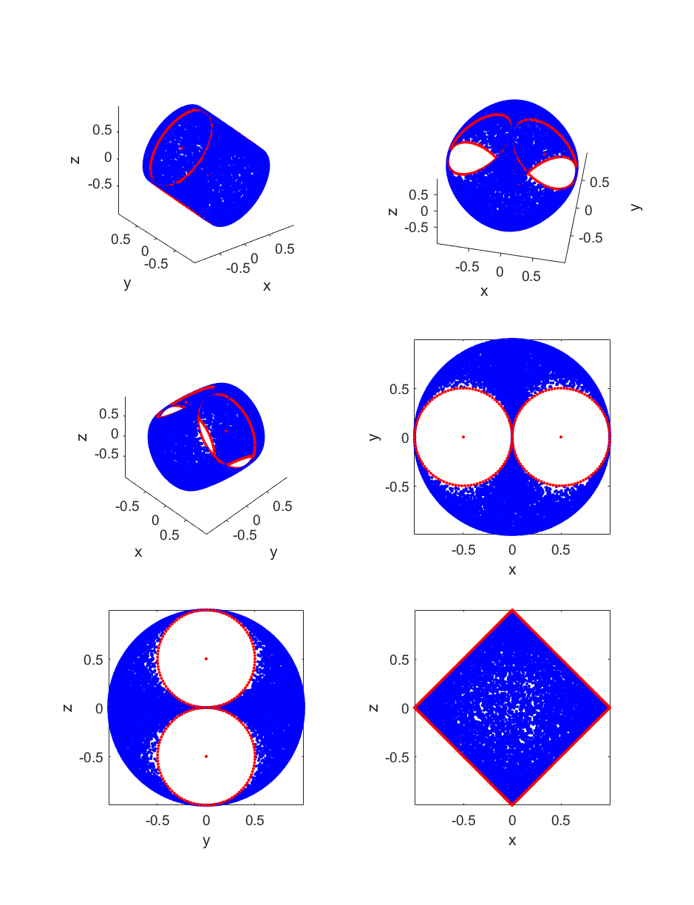

C(0,0)

B(0,-1)

## 3 Triangle

D

C(0,0)

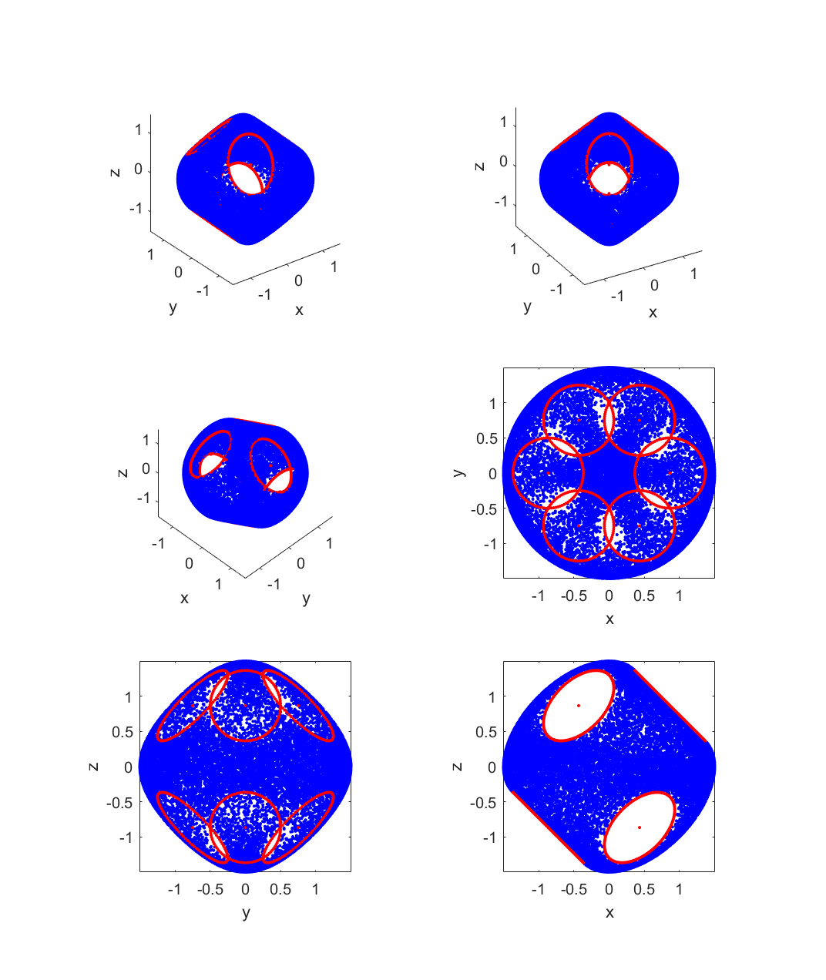

A

B

## 4 Square

E(1,1)

B(-1,1)

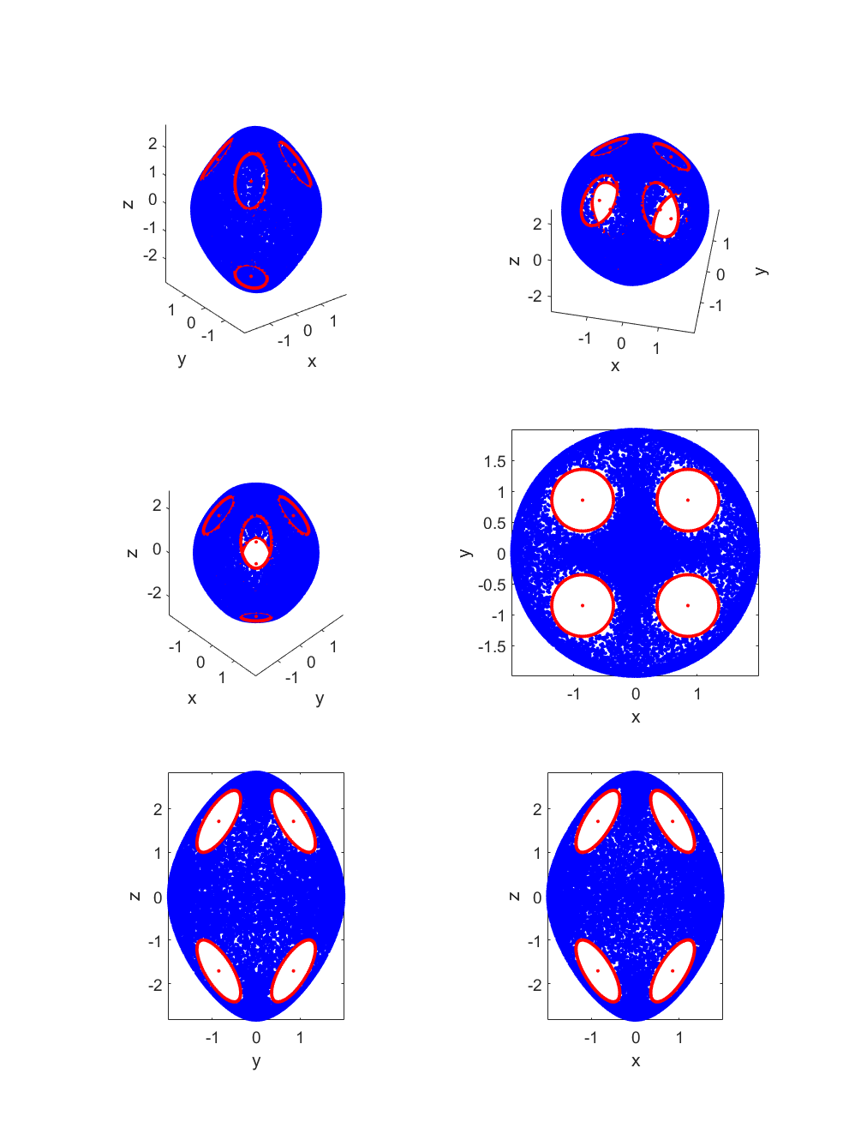

D(1,-1)

A(-1,-1)

C(0,0)

## 5 Continuous surfaces (Triangle)

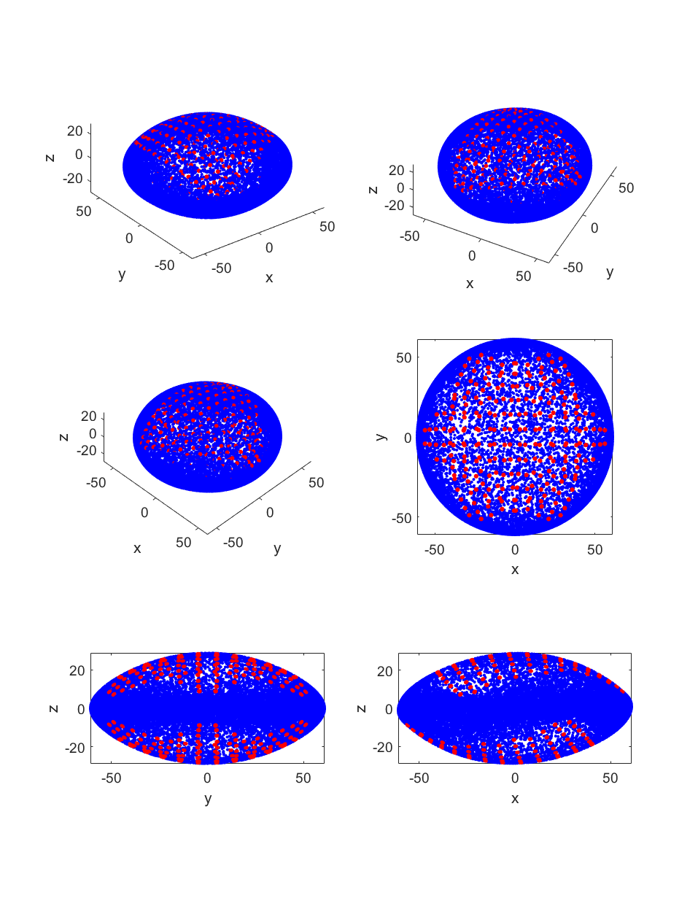

## 6 Continuous surfaces (Square)

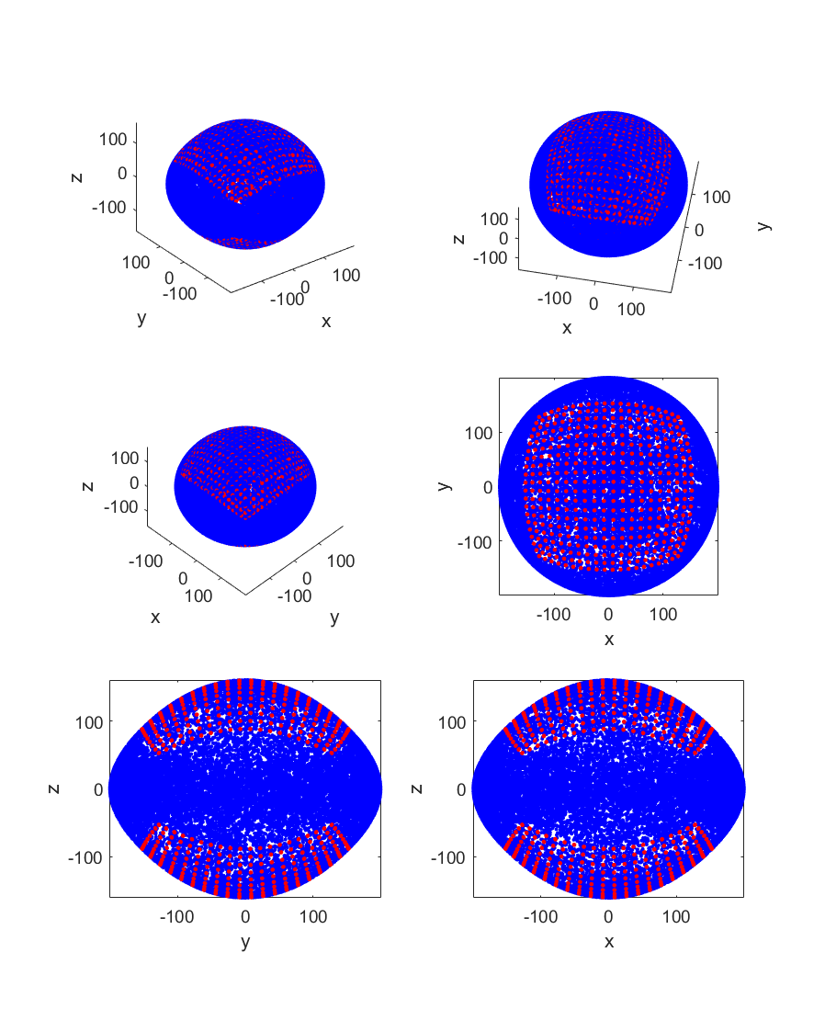

## 7 Continuous Surface (Randomly distributed square)

